Retirement Discovery Box
Gift your friend, employee, customer, client, and others with a fitting present to send them on their exciting retirement journey. Our Retirement Discovery box shown below is a great gift by itself. You can also enhance the box with selections shown on the next page, or items that you may choose to add on your own.
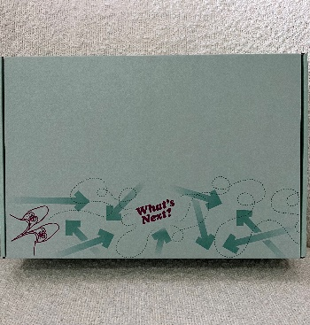

- 12.5 x 8.5 x 2.5 colorful sturdy box that can be mailed
- Encore Blueprint, Create Your Custom Designed Encore Life – our proprietary guide to thoughtfully planning the next chapter using a home building blueprint as your model.
- 65 Things to Do When You Retire – a collection of 65 easy-to-read essays that provide practical and entertaining advice about how to create a fulfilling retirement. The essays are written by a variety of recognizable names including Jimmy Carter, Gloria Steinem, John E. Nelson, Joan Price, as well as others who have created dynamic lives post retirement.
- I’m Retired. Now What? 52 Lists for Creating a Meaningful Future – a fun and creative journal for your client to list everything they want to do now that they finally have the time!
$87 each
- 5 x 7 Cheery “Congratulations” card that can be used as is or you can add messaging or signatures.

